**LEBANESE AMERICAN UNIVERSITY**

**USAID – HIGHER EDUCATION SCHOLARSHIP PROGRAM**

**HES - Volunteering Program Verification Form**

This form is to be used to document volunteering hours. If a student volunteers for multiple organizations, a separate form must be used for each organization. **This form must be turned in by the 28th of each month, the latest.**

I certify that the scholar Abdulrahman Kanaan completed a total of 5 hours of service at InnovaThrive.

The hours were completed hours as per the below:

Hours # 0 (date) _2/12 – 6/12_ (initials of supervisor) __A.K.___

Hours # 0 (date) _9/12 – 13/12_ (initials of supervisor) __A.K.___

Hours # 0 date) _16/12 – 20/12 (initials of supervisor) __A.K.___

Hours # 5 date) _23/12 - 27/12 (initials of supervisor) __A.K.___

Brief description of the activities the scholar performed or participated in:

The topic was about: Blockchain for Ensuring Transparency in Charitable Fundraising.  
I discussed:  
Decentralized ledgers for transparent donation tracking.  
Smart contracts to ensure funds are spent as promised.  
Applications:  
Enabling donors to track how their contributions are used in real-time.  
Ensuring accountability and reducing fraud in fundraising campaigns.  
Statistics: Blockchain has led to a 30% increase in donations to verified charities.  
Advantages:  
Increased donor confidence through transparent tracking.  
Disadvantages:  
Complexity in adoption by small charities.  
Challenges:  
Establishing widespread use of blockchain among small and medium-sized nonprofits.  
Future Research:  
Integrating blockchain with AI for impact analysis of charitable donations.  
Expanding blockchain adoption to international humanitarian efforts.

Written feedback about the scholar’s performance:

Abdulrahman Kanaan's research on blockchain for ensuring transparency in charitable fundraising was thorough and informative. However, his volunteering form was submitted late, which is unacceptable. It is crucial that deadlines are respected moving forward for the smooth progression of all tasks.

Please rate the overall performance of the scholar at your organization:

|  |  |  |  |
| --- | --- | --- | --- |
|  | Mastery (5) | Proficient (3) | Emerging (1) |
| **Problem solver** | X |  |  |
| **Engaged & Committed** | X |  |  |
| **Open-minded & multicultural** | X |  |  |

Signature

& stamp

__________________________

_

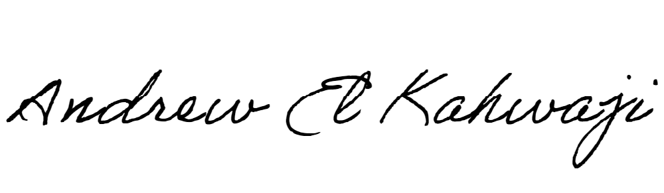

Printed Name _Andrew El Kahwaji_

Date __26/12/2024___

Email __andrew.lifesculptor.coo@gmail.com __

Phone __+961 71 914 378__